**Project Planning Phase**

**Project Planning Template (Product Backlog, Sprint Planning, Stories, Story points)**

|  |  |
| --- | --- |
| Date | 18 October 2022 |
| Team ID | PNT2022TMID28027 |
| Project Name | Personal Expense Tracker Application |
| Maximum Marks | 8 Marks |

**Product Backlog, Sprint Schedule, and Estimation (4 Marks)**

Use the below template to create product backlog and sprint schedule

| **Sprint** | **Functional Requirement (Epic)** | **User Story Number** | **User Story / Task** | **Story Points** | **Priority** | **Team Members** |
| --- | --- | --- | --- | --- | --- | --- |
| Sprint-1 | Registration | USN-1 | As a user, I can register for the application by entering my email, password, and confirming my password. | 3 | High | Varsha,  Rajashree |
| Sprint-1 | Login | USN-3 | As a user, I can log into the application by entering email & password | 2 | Low | Manjaarika |
| Sprint-1 |  | USN-4 | As a user, I can log into the application by entering user name & password | 1 | Low | Rajashree |
| Sprint-2 | Dashboard | USN-5 | As a user, I can enter into the dashboard to add transaction and salary | 2 | High | Shruthi,  Varsha |
| Sprint-2 |  | USN-6 | As a user ,I can view the transaction history and salary of a particular month. | 2 | Medium | Shruthi,  Manjaarika |
| Sprint-2 |  | USN-7 | As a user , I can view the current month balance | 2 | Medium | Varsha |
| Sprint-3 | Report | USN-8 | As a user, I can view the category wise transaction for a particular month in the form of pie chart | 3 | High | Manjaarika,  Rajashree |
| Sprint-3 |  | USN-9 | As a user , I can view the comparison between the previous year and current year transaction in the form of bar graph | 3 | high | varsha,  Rajashree |
| Sprint-4 | Watson Assistant | USN-10 | As a user, I can clarify the queries using chatbot | 2 | Low | Shruthi |
| Sprint-4 | SendGrid | USN-11 | As a user, I can receive Alerts and messages via email when it exceeds the certain a amount | 4 | High | Manjaarika,  Shruthi |

**Project Tracker, Velocity & Burndown Chart: (4 Marks)**

| **Sprint** | **Total Story Points** | **Duration** | **Sprint Start Date** | **Sprint End Date (Planned)** | **Story Points Completed (as on Planned End Date)** | **Sprint Release Date (Actual)** |
| --- | --- | --- | --- | --- | --- | --- |
| Sprint-1 | 6 | 6 Days | 24 Oct 2022 | 29 Oct 2022 | 6 | 29 Oct 2022 |
| Sprint-2 | 6 | 6 Days | 31 Oct 2022 | 05 Nov 2022 | 6 | 05 Nov 2022 |
| Sprint-3 | 6 | 6 Days | 07 Nov 2022 | 12 Nov 2022 | 6 | 12 Nov 2022 |
| Sprint-4 | 6 | 6 Days | 14 Nov 2022 | 19 Nov 2022 | 6 | 19 Nov 2022 |

**Velocity:**

Imagine we have a 6-day sprint duration, and the velocity of the team is 6 (points per sprint). Let’s calculate the team’s average velocity (AV) per iteration unit (story points per day)

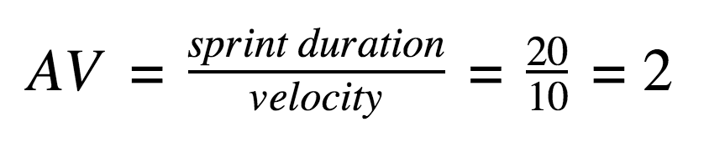

**=**6/6

=1